Primate pollination and the origins of the prehensile hand

Richard S. Moore
K. Anna. I. Nekaris

Wihermanto Soekendar

Abstract

Introduction
Nectar, a product of angiosperms, or flowering plants, is consumed by several species of non-flying mammal including marsupials, rodents and primates (Carthew & Goldingay 1997; Janson et al. 1981; Johnson et al. 2001). Nectar is a resource high in sugar, water and amino acids (Baker et al. 1998; Lüttge 1977) and provides an important food source, and potential water supply, to many species, especially in habitats characterised by distinct seasonality (Ferrari & Strier 1992; Garber 1988; Goldingay 1990; Johnson et al. 2001; Nicolson 2007; Smith 1982).
Accumulating evidence provides support for the theory, first proposed by Porsch (1934), that non-flying mammals can play an active role in pollination of angiosperm plants whilst feeding on plant products (Carthew & Goldingay 1997; Cunningham 1991). For successful pollination to take place pollen has to be transferred by the animal from one flower, to the stigma of another, preferably during a non-destructive feeding bout (Carthew & Goldingay 1997; Johnson et al. 2001). Unfortunately, obtaining evidence of this process is notoriously difficult, which is subsequently hindered by the fact that many of the species involved are nocturnal and cryptic (Carthew 1994; Kress et al. 1994).
In a review by Carthew and Goldingay (1997), 59 species of non-flying mammals were observed to be regularly visiting flowers, 28 of which were primates. Of the primate species associated with nectar feeding, as opposed to directly consuming flowers, small-bodied primates predominated (Carthew & Goldingay 1997; Ferrari & Strier 1992). The high energy, yet often patchily distributed, nectar supplies probably favour smaller-bodied primates, which benefit from high energy and easily digestible food resources, owing to their comparatively high metabolic rate (Ferrari & Strier 1992; Isbell 1998; Martin et al. 2007).
Amongst small-bodied strepsirrhine primates, numerous lemuriformes are at least partially nectivorous (See Gould et al. 2011; Sussman & Raven 1978), an adaptation that has been linked with potential pollination of angiosperms (Kress 1993; Kress et al. 1994; Overdorff 1992; Sussman & Raven 1978). In comparison, within the lorisformes, only Sciurocheirus gabonensis (Charles-Dominique 1977), Nycticebus coucang coucang (Wiens 2002; Wiens et al. 2006) and N. bengalensis (Swapna 2008) are currently recognised as partially nectivorous. Only the N. c. coucang in Malaysia had a considerable proportion of nectar in its diet, which made up 31.7% of total feeding time (Wiens 2002; Wiens et al. 2006). Studies of lemuriformes, however, are substantially more ubiquitous than those of lorisiformes, with only nine detailed studies of lorisiform feeding ecology to date. This paucity of studies, therefore, may be an influencing factor in the fewer records of nectivory in this suborder (Nekaris & Bearder 2011). Indeed, evidence from recent studies of an unnamed taxon of galago in southeastern Tanzania suggests nectar consumption is regular, as does recent data from N. pygmeaus in Cambodia (Nekaris & Bearder 2011).
Lorisine and perodicticine primates (lorises and pottos) are known for their characteristic slow, deliberate mode of locomotion and inability to leap (Charles-Dominique 1977; Ishida et al. 1992; Miller 1943). Instead of leaping, lorises and pottos use their long bodies and flexible limbs to stretch across canopy gaps in a manoeuvre known as cantilevering (Nekaris & Bearder 2011). Lorises and pottos exhibit a wide range of postural modes including quadrupedalism on horizontal substrates, and multiplane spinal movements and antipronograde postures during more acrobatic behaviours like climbing, cantilevering and suspensory activities (Charles-Dominique 1977; Nekaris 2001, 2005; Stern 1975). This array of locomotor capabilities in lorises and pottos are made possible by certain specialised morphological adaptations. These include relatively long limbs and transversely oriented lumbar zygapophyses for bridging, climbing and reaching, and retia mirabilia of the limb vessels and shortened second digits in the hands and feet for grasping (Bishop 1962; Rasmussen & Nekaris 1998; Shapiro 2007).
Within the Order Primates arboreality, particularly in the fine branch niche, and foraging amongst angiosperms, is associated with a number of hotly debated theories regarding primate origins (Rasmussen 1990; Sussman 1991). The earliest fossil evidence for euprimates comes from the early Eocene period, approximately 55 million years ago (Martin et al. 2007; Soligo & Martin 2006). Whilst interpretations of behaviour based on morphology of euprimates differ, a general consensus is that they were nocturnal, undergoing a transition from reliance on olfaction to vision, with increasingly enhanced stereoscopy (Cartmill 1992; Martin 1990). They were adapted to foraging in the terminal branches of trees, with fossil postcrania implying a shift toward manipulative abilities such as grasping hands, utilising their opposable halluxes and nails replacing claws (Cartmill 1992; Martin 1990; Sargis 2001). Stereoscopic vision and ability to grasp are two key features purported to distinguish the primate order from other eutherian mammals (Le Gros Clark 1959; Martin 1990).
These primate-like features were initially thought to be adaptations to a life of arboreality (Le Gros Clark 1959). More recently, however, morphological studies on other tree-dwelling mammals often revealed an absence of these characteristics, and suggest whilst arboreality was certainly a factor, alternative selection pressures prompted their manifestation (Cartmill 1972; Sussman 1974; Sussman 1991). Cartmill (1972) proposed that euprimate traits were adaptations to visual predation of insects in the terminal branch niche. He identified that grasping hands are advantageous to habitual foragers in terminal branches, allowing food item manipulation whilst in suspension, and that orbital convergence is a common characteristic in predatory animals that rely on vision to locate prey.
Sussman and Raven (1978) and Sussman (1991) postulated that euprimates, analogous to some extant to the nectar-feeding prosimians, were adapted to a period spent foraging in amongst angiosperms, which were purported to have emerged around the same time. The radiation of angiosperms provided a wealth of small food items such as flowers, nectar, pollen and fruits, which also attracted insects for the coevolving euprimates, who were beginning to utilise grasping hands, with or without stereoscopic vision, to exploit this new niche.
Rasmussen (1990) suspected that the characteristics, grasping hands and nails replacing claws, were the initial adaptations to foraging angiosperm products in the terminal branch milieu, and that stereoscopy evolved as adaptations to hunting live prey in this environment, where reliance on hearing or smell may not have been effective in the fine flexible branches. Rasmussen (1990) believed that the two previous hypotheses were not interdependent and were likely to influence each other as a driving force for evolution.
Here we investigate further the notion of potential non-flying mammals as pollinators, and consider the role that terminal branch feeding in primates has shaped their evolution. With a paucity of data on lorisiformes to date, we focus on feeding and positional behaviour of six rehabilitated and reintroduced Javan slow lorises (N. javanicus). We investigate the amount of floral nectar in their diet in the Gunung-Halimun Salak National Park, West Java, Indonesia using radio telemetry. We assess the position and movements of the Javan slow loris in the fine branch milieu in relation to its feeding behaviour and relate this to the known hypotheses regarding primate evolution.
Study Site
The study was conducted in the Gunung Halimun- Salak National Park, West Java, Indonesia on Salak Mountain (6°41'S, 106°44'E). Salak Mountain consists of lowland, submontane and montane forest and covers an area of approximately 76 km² (Supriatna 2006), although, this figure is likely to be less owing to gradual degradation and encroachment of park boundaries (Moore 2011). Primary forest is still present at higher altitudes, but secondary forest dominates the lower regions (Gjershaug et al. 2004), which is where the study was conducted. Salak Mountain is linked to the larger Halimun National Park by a narrow corridor (Prawiladilaga et al. 2008). Mean monthly minimum and maximum temperatures have a narrow range of 20 and 29 °C (Roosita et al. 2008). High annual rainfall reaches 4000–5000 mm, which is an important water catchment area (Gjershaug et al. 2004).

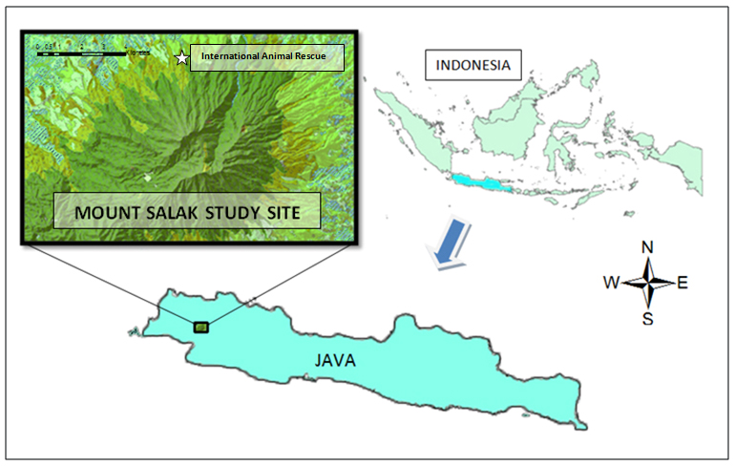

Methods
We followed six rehabilitated and reintroduced Javan slow lorises during April 2010 to March 2011 for periods ranging from two weeks to three months per animal. All animals were rescued from the pet trade and rehabilitated at International Animal Rescue centre, Bogor, Indonesia. We fitted Lorises with Biotrack radio-collars and located and tracked them using red halogen Petzl-zoom lamps, Biotrack antennas and R1000 Com-Spec receivers. We followed animals between 18.00–06.00 hours with two teams of three people monitoring for six hours each.

We recorded feeding observations using focal animal instantaneous scan sampling at five minute intervals (Altmann 1974; Martin & Bateson 2007). We identified flora food items to the species level, but for live prey items, to the ordinal level owing to visual difficulties. Lorises use a variety of different substrates and capture methods to acquire prey, so in order to quantify these actions, we recorded their exact position, the size of the substrate and method of food acquisition in each case (Nekaris 2005) Starr et al, in press). These included: whether the loris was in a quadrapedal position or in suspension; the size of the substrate (terminal, small but still flexible, medium and sturdy or trunk), and the food manipulation/capture technique (one hand, two hand or directly from mouth). When considering the consumption of floral parts and fruit, we noted whether hands were used in the manipulation of the flower/fruit stem during feeding; therefore, whilst the food item itself was not directly placed into the mouth using the hand, the stem was manipulated with the grasping extremities. We used non-parametric Chi-squared tests to analyse the data, with Yate’s correction where necessary. We used SPSS 17 for all analyses and accepted significance when p < 0.05 (Zar 1999).

Results
We collected 386 hours of data over 101 days. We witnessed 897 feeding observations during the focal scan sampling. The percentage of each food type consumed was: flowers (nectar and pollen) 89.97 %; animal prey, 4.46 %; fruit 3.32 %; and exudates 2.34 % (Table 1). Lorises consumed floral parts significantly more than other food groups (χ² = 1952.08, df = 3, p = < 0.001), and amongst the flower species, Calliandra calothyrsus was the preferred food item consumed (χ² = 1903.53, df = 3, p < 0.001). Foraging on flowers was significantly more common in terminal branches (χ² = 477.563, df = 2, p < 0.001) and comprised 66 % of incidences. When all feeding incidences are considered, foraging in terminal branches was also significantly more common (χ² = 788.40, df = 3, p < 0.001), making up 60 % of incidences. Foraging on small branches comprised 33 %, on medium branches 6 % and on the trunk 1 %. Lorises were exclusively arboreal foragers, only coming to ground occasionally in order to travel when canopy cover was lacking.

Table 1: Breakdown of food items consumed by lorises during the focal animal scans (n = 897).
Food item/ species | Sundanese name | Family | n | Within Group | Overall
 |  |  |  | Percent | Percent
Flower (n = 807)
Calliandra calothyrsus | Kaliandra | Fabaceae | 652 | 80.79
Plectocomia elongata | Bu buay | Arecaceae | 91 | 11.28
Cecropia peltata |  | Moraceae | 52 | 6.44
Piper aduncum | Seuseureuhan | Piperaceae | 8 | 0.99
Caryota rumphiana | Suwangkung | Arecaceae | 4 | 0.50 | 89.97
Animal Prey (n = 40)*
Lepidoptera | Kupu-kupu |  | 8 | 20.00
Hymenoptera | Semut |  | 5 | 12.50
Unidentified |  |  | 27 | 67.50 | 4.46
Fruit (n = 29)
Bellucia axinanthera | Jambu Tangkalak | Melastomataceae | 6 | 20.69
Dissochaeta gracillis | Ki Korong | Melastomataceae | 11 | 37.93
Villebrunea rubescens | Ki Nangsi | Urticaceae | 10 | 34.48
Maesopsis eminii | Kayu Afrika Manii | Rhamnaceae | 2 | 6.90 | 3.23
Exudates (n = 21)
Angiopteris evecta |  | Marattiaceae | 12 | 57.14
Paraserianthes falcataria | Jeungjing | Fabaceae | 3 | 14.29
Pinanga coronata | Bingbin | Arecaceae | 5 | 23.81
Unknown |  |  | 1 | 4.76 | 2.34
* Animal prey was identified to ordinal level where possible

During bouts of flower feeding, lorises would systematically move around the whole tree visiting every flower, using primarily vision to identify their next floral candidate. Scent was used when approaching the flower, but seemingly only after the loris had already located it visually. On sighting a flower, the loris would proceed to move quickly towards that flower. If no direct route was available, the loris would move back towards the tree trunk into the sturdier branches, locate the branch the flower was on, and then move out into the terminal branches again to feed. When feeding on flower parts, one hand was used to manipulate the stem or flower in 53 % of incidences, two hands were used 38% of incidences and just orally 9 % (n = 797). Lorises engaged in significantly more suspensory positions whilst flower feeding (χ² = 29.95, df_{Yates} = 1, p < 0.001), and also when considering all feeding incidences combined (χ² = 31.09, df_{Yates} = 1, p < 0.001). The trunk was never used during flower consumption. For flowers located on terminal branches out of immediate reach, the loris was observed to grab the stem with one hand, pull it in, and subsequently walk its hands up the stem until the flower was close enough to reach with the mouth (Figure 3).
A similar action involving manipulation of terminal branches was observed whilst bridging gaps between flower trees and has also been reported by Charles-Dominique (1977) in pottos and Nekaris (2001) in slender lorises. Lorises are unable to leap, however, on numerous occasions when a break in canopy was encountered this particular bridging manoeuvre was employed. Whilst its hind feet were securely fixed in a cantilever position, the loris would lunge its body forward with arms stretched out, either swinging the branch forward manually, or by utilising gusts of wind to increase its reach. On grasping a terminal branch on the opposite side of the gap, the loris would then pull this branch in, walking its hands up the branch until it became large enough to support its weight. The loris then released a hind leg from the previous branch, stretching it up to 180° horizontally, and positioning it on the new branch. When the loris was stable, it would release the remaining leg, often plummeting downwards under its weight, but still holding the branch. The loris would then climb up the branch once it had ceased swinging (Fig ?).
Nectar was the desired flower part in all cases of feeding from C. calothyrsus. Lorises fed on a single flower for a mean duration of 17 seconds (SD ± 12.7, n = 33). Feeding on C. calothyrsus was observed all year round, although seasonal differences were not investigated here. The flower was never observed to be damaged during feeding. Owing to difficulties in viewing at night, even with red halogen lights, it was not possible to determine in most flower feeding incidences, whether pollen was collecting on the body of the animal before moving off to the next flower. On three separate occasions, however, the loris was close enough to observe that pollen was present on its face.
Whilst catching animal prey, sturdier small and medium substrates were preferred to the terminal branches and trunks (χ² = 39.340, df = 3, p ≤ 0.001). One-handed and two-handed grabs were employed to catch live prey significantly more times than directly by mouth (χ² = 11.40, df = 2, p ≤ 0.01), with one-handed grabs being the preferred option comprising 49 % of incidences. Consumption of arthropods was prevalent in the animal prey category, although many could not be identified. Feeding on Hymenoptera (ants) was the only animal prey taken directly by mouth on all occasions. After feeding on ants the loris was occasionally observed to violently shake its head, presumably from the biting ants crawling over the loris’ face. Outside the scans, lorises were observed to consume lizards on two occasions (Order: Squamata), and on one occasion the attempted capture of a small roosting bird was observed, but was unsuccessful.
Consumption of fruit was undertaken using all three food capture/manipulation techniques with no significant preference towards any one method (χ² = 0.545, df = 2, p ≥ 0.05). Small branches were utilised significantly more whilst feeding on fruits (χ² = 10.52, df = 3, p ≤ 0.05) and whilst suspensory positions were employed more often than not (61 % to 39 % respectively, n = 33) there was no significant difference (χ² = 1.485, df_{Yates} = 1, p ≥ 0.05).
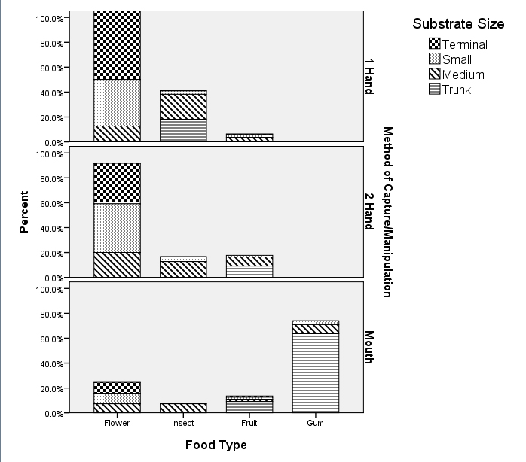
Feeding on exudates only constituted a small proportion of the diet, and this action never involved any hand manipulation. Exudates consisted predominantly of sap from already open tree wounds, which were consumed orally. On only one occasion the loris was observed scraping hardened gum from an unidentified tree. Choice of substrate use during exudates consumption was not significant (χ² = 1.9, df = 2, p ≥ 0.05), although terminal branches were never used. Suspensory positions were employed significantly more when feeding on exudates (85 % to 15 % respectively) (χ² = 9.8, df_{Yates} = 1, p ≤ 0.01).
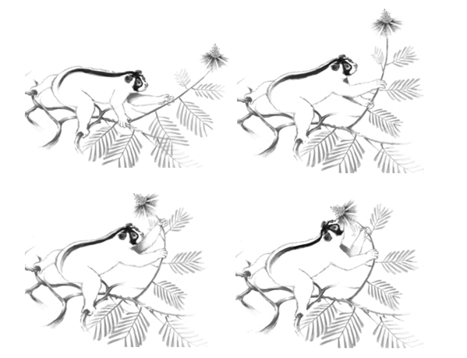
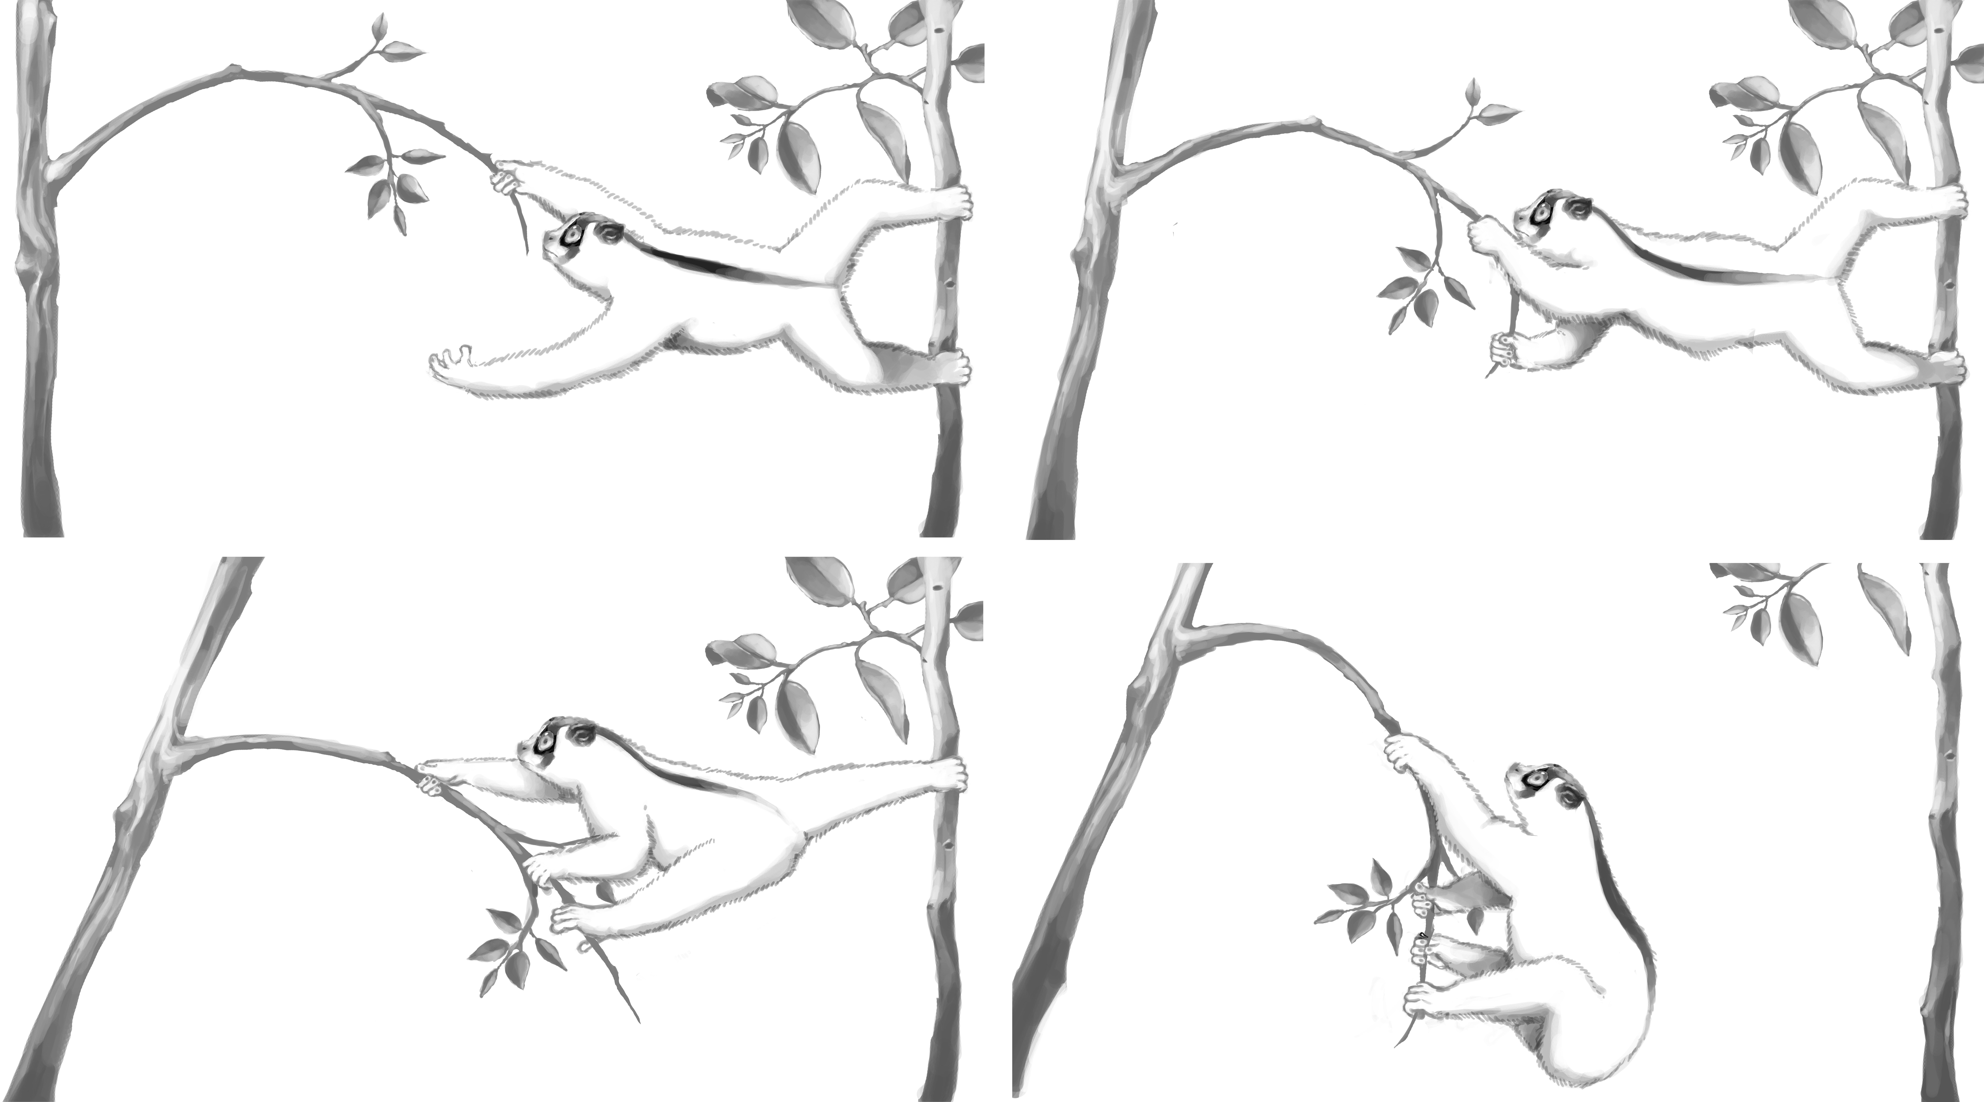

Discussion
The reintroduced Javan slow lorises consumed a variety of foods; however, they fed significantly more on the floral nectar of C. calothyrsus than on other food types. Although seasonality in flower feeding was not assessed, nectar feeding was observed throughout the year. An unpublished study of N. javanicus also reported regular feeding on C. calothyrsus in Java, although frequencies were not recorded (Arisona 2008). Nycticebus c. coucang in Malaysia displayed similar behaviour where a substantial proportion of the feeding time (31 %) was devoted to floral nectar, specifically, the Bertram Palm (Eugeissona tristis), which constituted 41 % of all counts (Wiens 2002; Wiens & Zitzmann 2003).
Compared to other species of loris, however, feeding behaviour was not analogous with our findings. Slender lorises (Lorisinae), for example, forage almost exclusively on animal prey (Nekaris 2005, 2003) whereas Bengal and pygmy slow lorises reveal a preference for exudates (Nekaris et al. 2010; Swapna et al. 2010). Whilst these food types were consumed by Javan slow lorises, they only constituted a small proportion of the overall diet.
This inconsistency in findings, however, may be a consequence of different sampling techniques (Rose 2000). In the study by Nekaris (2005), all occurrence sampling was used, compared to the focal animal instantaneous sampling in this study. Capture and consumption of animal prey by lorises can be a very swift process (MacNeilage 1990; Nekaris 2005), therefore, all occurrence sampling may be better suited to recording this type of rapid event. Focal animal instantaneous scan sampling was chosen in this study owing to the sheer number, and often lengthy nature, of flower feeding events, which may help to avoid sampling bias. If all occurrence sampling was used in this study, capture of animal prey incidences would indeed rise; however, so too would flower feeding. Another potential area of bias in this study relates to difficulties following lorises in extremely treacherous terrain. Some areas within the lorises range could not be accessed owing to steep-sided ravines. Therefore, some caution is needed when considering these data.
Javan slow lorises foraged significantly more in the terminal branches than in other substrate categories comprising 60 % of all feeding incidences. Lorises appeared highly adapted to the fine branch milieu displaying a number of postures and techniques that allowed them to exploit this niche readily. In accordance with slender lorises, at least two limbs were always in contact with branch during flower/fruit stem manipulation or hunting of animal prey (Nekaris 2005). One-handed manipulation or grabs were the preferred method of food acquisition, although two-handed manipulation and grabs were also common. Indeed, slender lorises and pottos also forage live prey in this manner (Nekaris 2005; Pimley 2002). Two lorises were observed briefly travelling terrestrially, but never to forage. In both cases, it was to cross a cleared area where canopy was lacking. They descended to the ground and swiftly made their way across to the next tree.
Vision appeared to be the most important sense in location of C. calothyrsus flowers from a close range, not only in locating flowers, but also in choosing an appropriate route to get there. Olfaction may be of use to locate the flowering trees from a distance, although this would need to be confirmed. Once amongst the flowers, however, owing to their position and sheer abundance, other senses may not be as effective as vision. Audition is obviously ineffective in locating flowers, and olfaction may be hampered by short distances between flowers. Strong gusts of wind could disperse the scent from the flowers, and also cause the branches to move vigorously, therefore, confusing the origin of the smell. Capture of live prey also involved vision and is comparable to the findings in slender lorises (Nekaris 2005) and pottos (Pimley 2002) and reinforces the importance of vision as the predominant sense in the feeding ecology of these primates.
Calliandra calothyrsus trees were abundant at the Mount Salak study site (Mirmanto et al. 2008) and the lorises would actively search them out. Depending on tree size and profusion of flowers, the lorises would remain in the same tree or group of trees until all flowers had been visited. The Bertram palm flowers fed on by N. c. coucang during a study by Wiens and Zitzmann (2006) comprised several hundred flowers in one inflorescence and often contained copious amounts of nectar in a localised area. In comparison, flowers of C. calothyrsus are patchily distributed, located on the outermost tips of the branches, and undoubtedly require a great deal more movement in the terminal branches to access.
The genus Calliandra is native to Mexico, Central and South America, and C. calothyrsus was first introduced to Indonesia from Guatemala in 1936 by Dutch botanists (Chamberlain & Hubert 2001; MacQueen 1992). Calliandra calothyrsus is used principally as a source of cattle fodder and fuel wood, but also for manure, erosion control and honey production (Chamberlain & Hubert 2001; Moore 2011). Numbers of flowers per inflorescence range from 1 – 34, open over a period of 60 -90 days, and can be found from the base to the tip. If sufficient moisture is available the C. calothyrsus can flower throughout the year, although peaks between November and January (Chamberlain & Hubert 2001). Continuous flowering, therefore, potentially provides a constant food source to lorises and other flower visitors.

Calliandra calothyrsus becomes florally receptive during late afternoon and nectar is produced during the night, suggesting an evolved dependence on nocturnal visitors for pollination. Whilst bees and wasps are known to visit this flower, they are only regarded as “nectar robbers”, as the morphology of the flower allows them access to the nectar without coming into contact with the reproductive parts (Chamberlain & Hubert 2001). Larger insects or mammals such as bats that would rub against the stamen whilst feeding are therefore the more likely pollinating candidates. Indeed, MacQueen (1992) suggested nectar feeding or long-tongue bats (Glossophaga spp.) were the primary pollinators of C. calothyrsus in Honduras. The bats regularly came into contact with the staminal brush, and pollen could be seen clearly on the underside of their bodies.

Javan slow lorises on Mount Salak appear to be highly dependent on nectar as a food source throughout the year. Lorises fed on nectar from many flowers a night, from different trees, and without damaging the flowers. When combined with the facts that pollen was observed on the face of the loris, and that the flower morphology of C. calothyrsus could accommodate small mammals, the available evidence appears to support the theory by Porsch (1934) that non-flying mammals are potential pollinators of angiosperms. Whether resident lorises are the sole pollinators of C. calothyrsus in this region is unlikely. Various species of nectar feeding bat (Family: Macroglossinae and Pteropodidae) also inhabit Mount Salak (Prawiladilaga et al. 2008), and bats are known pollinators of this species elsewhere (MacQueen 1992). Bats were never observed visiting C. calothyrsus flowers during our study.

Sussman’s Angiosperm Co-evolution Hypothesis suggested that grasping hands and possibly stereoscopic vision were euprimate adaptations for foraging on nectar, flowers and fruit, which emerged during a co-evolution period with angiosperms. Rasmussen’s synthesised view incorporated both the Angiosperm Co-evolution and Cartmill’s Visusal Predation hypotheses. Arboreal, highly necitvorous and potential pollinators of C. calothyrsus, the behaviours of Javan slow lorises in the present study do appear to support to the angiosperm related hypotheses of Sussman and Rasmussen. Although, as C. calothyrsus is a non-native flower to Indonesia, any possibility of co-evolution between these two species can be immediately disregarded. However, as our study site is located in secondary forest, the nectivorous habits observed here may also feature in the diet of Javan slow lorises in less disturbed forests, but involving more archaic species.

Cartmill (1992) had criticised the Angiosperm Co-evolution hypothesis arguing that stereoscopic vision would not be a prerequisite when foraging for sedentary items such as flowers or fruit. Javan slow lorises in this study, however, reveal how marked optic convergence may be of use in locating appropriate flowers in a three-dimensional network of swaying terminal branches where smell is overwhelming and hearing is irrelevant. Indeed, some species of nectivorous megachirpoteran bats also possess a degree of optic convergence with primate-like visual components in the brain (Barclay 2002; Pettigrew et al. 1989; Sussman 1995).

(Cartmill 1992) also noted that the dental anatomy of the predominantly nectivorous bats are in no way comparable to euprimate dentition, which indicate fruit, insect or leaf eating adaptations. (Martin 1979), however, suggested that not all dietary habits of a species would be represented in the dentocranial morphology, and should only be used tentatively when assigning diets to species in this way. Indeed, some primate species with the same dental morphology can differ in diet owing simply to their location in a different habitat (Sheine & Kay 1982). Moreover, in the absence of dental indications of nectivory, ‘evolutionary inertia’, where morphological adaptations can trail behind actual behavioural traits, may be a factor (Martin 1979). Rapid changes in behaviour or diet often coincide with environmental changes, whereas changes in dental morphology are not so fast (Richard 1985). Nevertheless, whilst loris dentition may not directly suggest nectivory, an area needing further investigation is tongue morphology. Preliminary reports suggests different tongue lengths within Javan slow loris species, some of which feature brush-like feathered tongues as seen in nectar feeding red-bellied lemur (Eulemur rubriuenter) (Overdorff 1992).

Sussman (1991) proposed that grasping hands were an adaptation to fruit eating as it enabled euprimates to cling and feed amongst the terminal branches without needing to return back to sturdier supports. Cartmill (1992), however, noted that fruit bearing plants occurred much later in the Cenozoic, which would not have coincided with earlier fossil evidence of grasping capabilities in the Cretaceous. Could flowers, therefore, have been the evolutionary driver for primate prehensile extremities? Lorisiformes are renowned for their whole-hand power-grip, with forceps-like design, applied during the capture of animal prey or whilst firmly gripping branches (Bishop 1962; MacNeilage 1990; Napier 1960), but far less so for dexterous manipulation of food items. During flower stem manipulation in this study, Javan slow lorises exhibited a precise and delicate gripping ability whilst slowly luring the flower towards them. This action clearly demonstrates grip regulation, as opposed to the often ‘stereotypically performed’ power-grip observed in other lorisiforms (Bishop 1962; MacNeilage 1990). Perhaps the fundamental difference in feeding on flowers compared to fruit is that, from a reproductive perspective, if a flower is destroyed or consumed the plant’s fitness is reduced. If co-evolution between primates and angiosperms has occurred, we would expect the flower to be left unharmed by the primate after feeding. The delicate precision grip, as observed in Javan slow lorises, helps to ensure the flower is not damaged during feeding. Whether this manipulating ability arose during a period of co-evolution is uncertain, however, these preliminary findings warrant further investigation.

References

Altmann, J. 1974. Observational Study of Behavior: Sampling Methods. Behaviour, 49, 227-267.
Arisona, J. 2008. Studi Perilaku dan Ekologi Kukang Jawa (Nycticebus javanicus Geoffroy, 1812) di Kawasan Hutan Bodogol, Taman Nasional Gunung Gede Pangrango, Jawa Barat, Universitas Indonesia.
Baker, H. G., Baker, I. & Hodges, S. A. 1998. Sugar Composition of Nectars and Fruits Consumed by Birds and Bats in the Tropics and Subtropics. Biotropica, 30, 559-586.
Barclay, R. M. R. 2002. Do Plants Pollinated by Flying Fox Bats (Megachiroptera) Provide an Extra Calcium Reward in Their Nectar? Biotropica, 34, 168-171.
Bishop, A. 1962. Control of the hand in lower primates. Annals of the New York Academy of Sciences, 102, 316-337.
Carthew, S. M. 1994. Foraging Behaviour of Marsupial Pollinators in a Population of Banksia spinulosa. Oikos, 69, 133-139.
Carthew, S. M. & Goldingay, R. L. 1997. Non-flying mammals as pollinators. Trends in Ecology & Evolution, 12, 104-108.
Cartmill, M. 1972. Arboreal adaptations and the origin of the order Primates. In: The functional and evolutionary biology of primates (Ed. by R. Tuttle), pp. 97-122. Chigago: Aldine.
Cartmill, M. 1992. New views on primate origins. Evolutionary Anthropology: Issues, News, and Reviews, 1, 105-111.
Chamberlain, J. R. & Hubert, J. D. 2001. Reproductive biology and seed production. In: Calliandra calothyrsus: An agroforestry tree for the humid tropics (Ed. by J. R. Chamberlain), pp. 12-28. Oxford: Oxford University Press.
Charles-Dominique, P. 1977. Ecology and behaviour of nocturnal primates: prosimians of equatorial West Africa: Columbia University Press.
Cunningham, S. A. 1991. Experimental evidence for pollination of &lt;i&gt;Banksia&lt;/i&gt; spp. by non-flying mammals. Oecologia, 87, 86-90.
Ferrari, S. F. & Strier, K. B. 1992. Exploitation of Mabea fistulifera Nectar by Marmosets (Callithrix flaviceps) and Muriquis (Brachyteles arachnoides) in South-East Brazil. Journal of Tropical Ecology, 8, 225-239.
Garber, P. A. 1988. Foraging Decisions During Nectar Feeding by Tamarin Monkeys (Saguinus mystax and Saguinus fuscicollis, Callitrichidae, Primates) in Amazonian Peru. Biotropica, 20, 100-106.
Gjershaug, J. O., Røv, N., Nyård, T., Prawiradilaga, D. M., Afianto, M. Y., Hapsoro & Supriatna, A. 2004. Home-range size of the Javan Hawk-Eagle Spizaetus bartelsi estimated from direct observation and radiotelemetry. Journal of Raptor Research, 38, 343-349.
Goldingay, R. L. 1990. The Foraging Behaviour of a Nectar Feeding Marsupial, Petaurus australis. Oecologia, 85, 191-199.
Gould, L., Sauther, M. & Cameron, A. 2011. Lemuriformes. In: Primates in Perspective (Ed. by C. J. Campbell, A. Fuentes, K. C. MacKinnon, S. K. Bearder & R. M. Stumpf). Oxford: Oxford University Press.
Isbell, L. A. 1998. Diet for a small primate: Insectivory and gummivory in the (large) patas monkey (Erythrocebus patas pyrrhonotus). American Journal of Primatology, 45, 381-398.
Ishida, H., Hirasaki, E. & Matano, S. 1992. Locomotion of the slow loris between discontinuous substrates. In: Topics in primatology. Vol. 3. Evolutionary biology, reproductive endocrinology, and virology. (Ed. by S. Matano, R. H. Tuttle, H. Ishida & M. Goodman), pp. 139-152 Tokyo: University of Tokyo Press.
Janson, C. H., Terborgh, J. & Emmons, L. H. 1981. Non-Flying Mammals as Pollinating Agents in the Amazonian Forest. Biotropica, 13, 1-6.
Johnson, S. D., Anton, P. & Midgley, J. 2001. Rodent Pollination in the African Lily Massonia depressa (Hyacinthaceae). American Journal of Botany, 88, 1768-1773.
Kress, W. J. 1993. Coevolution of plants and animals : pollination of flowers by primates in Madagascar. Bangalore, INDE: Current Science Association.
Kress, W. J., Schatz, G. E., Andrianifahanana, M. & Morland, H. S. 1994. Pollination of Ravenala madagascariensis (Strelitziaceae) by Lemurs in Madagascar: Evidence for an Archaic Coevolutionary System? American Journal of Botany, 81, 542-551.
Le Gros Clark, W. E. 1959. The antecedents of man: an introduction to the evolution of the Primates: University Press.
Lüttge, U. 1977. Nectar composition and membrane transport of sugars and amino acids : a review on the present state of nectar research. Apidologie, 8, 305-319.
MacNeilage, P. F. 1990. Grasping in modern primates: the evolutionary context. In: Vision and action: the control of grasping (Ed. by M. A. Goodale), pp. 1-13. New Jersey: Ablex Publishing Corporation.
MacQueen, D. J. 1992. Calliandra calothyrsus: implications of plant taxonomy, ecology and biology for seed collection. Commonwealth Forestry Review., 71, 20-34.
Martin, P. & Bateson, P. 2007. Measuring behaviour : an introductory guide. Cambridge [etc.]: Cambridge University Press.
Martin, R. 1990. Primate Origins and Evolution: Chapman & Hall.
Martin, R. D. 1979. Phylogenetic aspects of prosimian behavior. In: The Study of Prosimian Behavior (Ed. by G. A. Doyle & R. D. Martin), pp. 45-75. New York: Academic Press.
Martin, R. D., Soligo, C. & Tavaré, S. 2007. Primate Origins: Implications of a Cretaceous Ancestry. Folia Primatologica, 78, 277-296.
Miller, R. A. 1943. Functional and morphological adaptations in the forelimbs of the slow lemurs. American Journal of Anatomy, 73, 153-183.
Mirmanto, E., Wiriadinata, H., Royyani, M. F., Ichikawa, S. & Ismirza. 2008. Merajut pesona flora hutan pegunungan tropis di Gunung Salak. Jakarta: Pusat Penelitian Biologi LIPI.
Moore, R. S. 2011. Sightings of Javan Small-toothed Palm Civets Arctogalidia trivirgata trilineata on Gunung Salak, West Java, Indonesia. Small Carnivore Conservation, 44.
Napier, J. R. 1960. Studies of the hands of living primates. Proceedings of the Zoological Society of London, 134, 647-657.
Nekaris, K. A.-I., Starr, C. R., Collins, R. L. & Wilson, A. 2010. Comparative Ecology of Exudate Feeding by Lorises (Nycticebus, Loris) and Pottos (Perodicticus, Arctocebus). In: The Evolution of Exudativory in Primates (Ed. by A. M. Burrows & L. T. Nash), pp. 155-168: Springer New York.
Nekaris, K. A. I. 2001. Activity budget and positional behavior of the Mysore slender loris (Loris tardigradus lydekkerianus): Implications for slow climbing locomotion. Folia Primatologica, 72, 228-241.
Nekaris, K. A. I. 2005. Foraging behaviour of the slender loris (Loris lydekkerianus lydekkerianus): implications for theories of primate origins. Journal of Human Evolution, 49, 289-300.
Nekaris, K. A. I. 2003. Spacing system of the Mysore slender loris (Loris lydekkerianus lydekkerianus). American Journal of Physical Anthropology, 121, 86-96.
Nekaris, K. A. I. & Bearder, S. K. 2011. The Lorisiform Primates of Asia and Mainland Africa: Diversity Shrouded in Darkness. In: Primates in Perspective (Ed. by C. J. Campbell, A. Fuentes, K. C. MacKinnon, S. K. Bearder & R. M. Stumpf). Oxford: Oxford University Press.
Nicolson, S. W. 2007. Nectar consumers
Nectaries and Nectar. (Ed. by S. W. Nicolson, M. Nepi & E. Pacini), pp. 289-342: Springer Netherlands.
Overdorff, D. J. 1992. Differential patterns in flower feeding by Eulemur fulvus rufus and Eulemur rubriventer in Madagascar. American Journal of Primatology, 28, 191-203.
Pettigrew, J. D., Jamieson, B. G. M., Robson, S. K., Hall, L. S., McAnally, K. I. & Cooper, H. M. 1989. Phylogenetic Relations Between Microbats, Megabats and Primates (Mammalia: Chiroptera and Primates). Philosophical Transactions of the Royal Society of London. Series B, Biological Sciences, 325, 489-559.
Pimley, E. R. 2002. The behavioural ecology and genetics of two nocturnal prosimians: Pottos (Perodicticus potto edwardsi) and Allen´s bushbabies (Galago alleni cameronensis). University of Cambridge.
Porsch, O. 1934. Sdugetiere als Blumenausbeuter und die Frage der Siugetierblume. . Biologia Generalis, 10, 657-685.
Prawiladilaga et al., D. M. 2008. Fauna Survey at Resort Kawah Ratu - Gunung Salak, Gunung Halimun-Salak NP. Bogor: Division of Zoology, LIPI.
Rasmussen, D. T. 1990. Primate origins: Lessons from a neotropical marsupial. American Journal of Primatology, 22, 263-277.
Rasmussen, T. D. & Nekaris, K. 1998. Evolutionary History of Lorisiform Primates. Folia Primatologica, 69, 250-285.
Richard, A. F. 1985. Primates in Nature. New York: W. H. Freeman and Company.
Roosita, K., Kusharto, C. M., Sekiyama, M., Fachrurozi, Y. & Ohtsuka, R. 2008. Medicinal plants used by the villagers of a Sundanese community in West Java, Indonesia. Journal of Ethnopharmacology, 115, 72-81.
Rose, L. M. 2000. Behavioral Sampling in the Field: Continuous Focal versus Focal Interval Sampling. Behaviour, 137, 153-180.
Sargis, E. J. 2001. The grasping behaviour, locomotion and substrate use of the tree shrews Tupaia minor and T. tana (Mammalia, Scandentia). Journal of Zoology, 253, 485-490.
Shapiro, L. J. 2007. Morphological and functional differentiation in the lumbar spine of lorisids and galagids. American Journal of Primatology, 69, 86-102.
Sheine, W. S. & Kay, R. F. 1982. A model for comparison of masticatory effectiveness in primates. Journal of Morphology, 172, 139-149.
Smith, A. P. 1982. Diet and Feeding Strategies of the Marsupial Sugar Glider in Temperate Australia. Journal of Animal Ecology, 51, 149-166.
Soligo, C. & Martin, R. D. 2006. Adaptive origins of primates revisited. Journal of Human Evolution, 50, 414-430.
Stern, J. J. T. 1975. Before bipedality. Yearbook of Physical Anthropology, 19, 59-68.
Supriatna, J. 2006. Conservation Programs for the Endangered Javan Gibbon (Hylobates moloch). Primate Conservation, 155-162.
Sussman, R. W. 1974. Ecological distinctions in sympatric species of Lemur. In: Prosimian Biology (Ed. by R. O. Martin, G. A. Doyle & A. C. Walker). London: Duckworth.
Sussman, R. W. 1995. How primates invented the rainforest and vice versa. In: Creatures of the Dark: The Nocturnal Prosimians (Ed. by L. Alterman, G. A. Doyle & M. K. Izard), pp. 1-10. New York: Plenum Press.
Sussman, R. W. 1991. Primate origins and the evolution of angiosperms. American Journal of Primatology, 23, 209-223.
Sussman, R. W. & Raven, P. H. 1978. Pollination by Lemurs and Marsupials: An Archaic Coevolutionary System. Science, 200, 731-736.
Swapna, N. 2008. Assessing the feeding ecology of the Bengal slow loris (Nycticebus bengalensis) in Trishna Wildlife Sanctuary, Tripura, Manipal University.
Swapna, N., Radhakrishna, S., Gupta, A. K. & Kumar, A. 2010. Exudativory in the Bengal Slow Loris (Nycticebus bengalensis) in Trishna Wildlife Sanctuary, Tripura, Northeast India. American Journal of Primatology, 72, 113-121.
Wiens, F. 2002. Behavior and Ecology of Wild Slow Lorises (Nycticebus coucang): Social Organization, Infant Care System, and Diet, Universitat Bayreuth.
Wiens, F. & Zitzmann, A. 2003. Social structure of the solitary slow loris Nycticebus coucang (Lorisidae). Journal of Zoology, 261, 35-46.
Wiens, F., Zitzmann, A. & Hussein, N. A. 2006. Fast food for slow lorises: Is low metabolism related to secondary compounds in high-energy plant diet? Journal of Mammalogy, 87, 790-798.
Zar, J. H. 1999. Biostatistical analysis. Upper Saddle River, NJ: Prentice Hall.

